Once you have created your log in credentials, you may sign back in to the ARPA application by following the steps below.
From the homepage douglascountyks.org, click the icon in the upper right-hand corner of the homepage.

Enter log in credentials and follow the CAPTCHA prompts
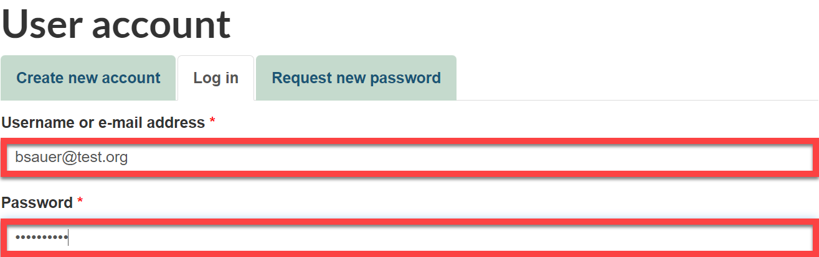
Once logged in, a “Log in successful…” message displays
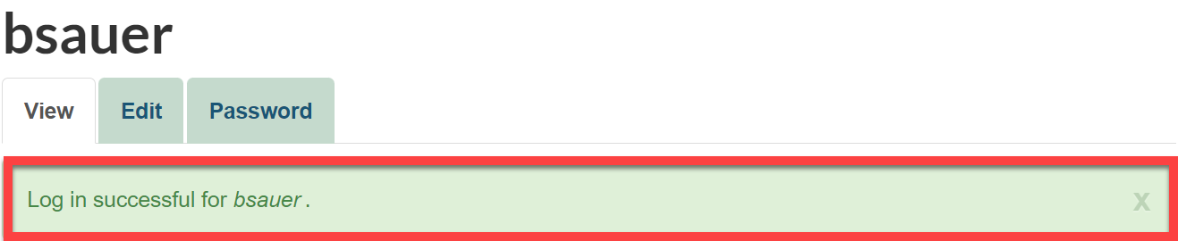
On that same screen, search ‘arpa’ in the upper right-hand corner
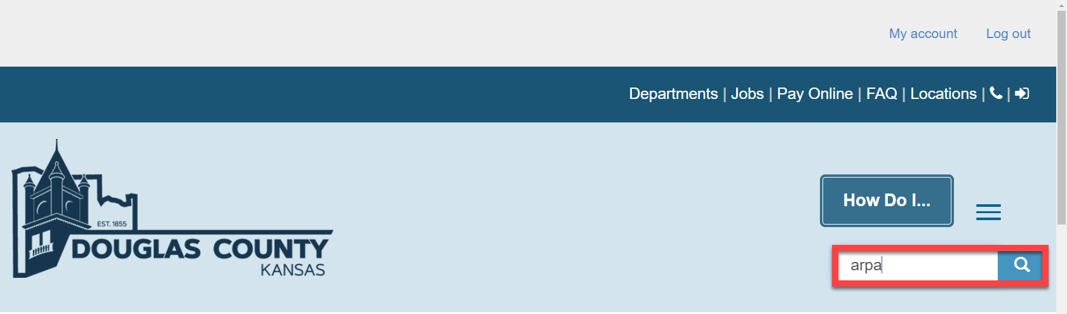

Select the search result shown below:
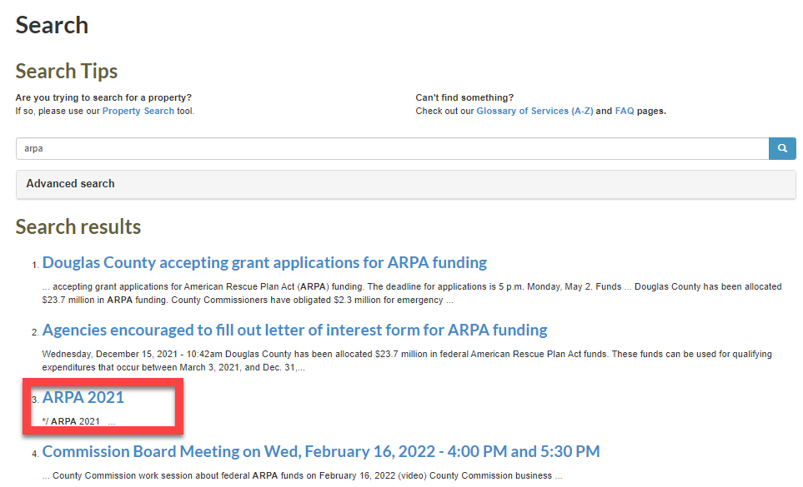
Once you click on the link to go to the form, the form page will load from where entries were left off and a message displays at the top of the form indicating that there is a draft form.
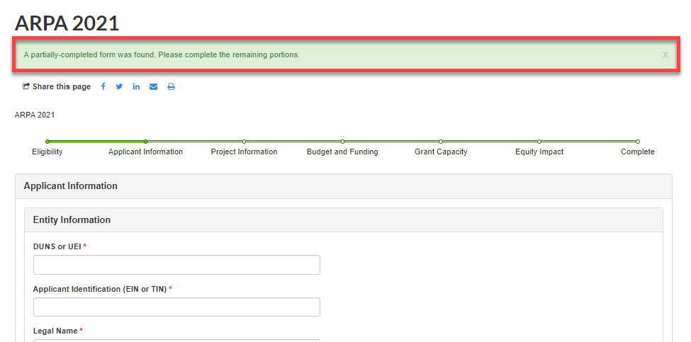

Tip…
Remember to save the draft before advancing to the next page.
