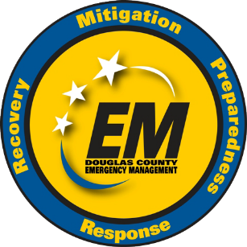
Volunteer Application

Douglas County Emergency Management
111 East Eleventh Street, Unit 200
Lawrence, Kansas 66044-2909
Office: (785) 832-5259

Please complete this form and submit via Email or Mail

Volunteer Information
Full Name
Preferred Pronouns Date
Street Address
Apartment/Unit Number
City State Postal Code
Phone Number Cell Phone Number
Receive Cell Phone Text Messages Yes No
Email Address

Employment
Current Employment Status Employed Not Employed Retired Student

If employed, complete the following:
Employer
Address of Employer
Employer Phone Length of Time

Education and Special Skills
Level of Highest Education Completed GED/High School College Vocational Training
Name of High School Attended
Name of College(s) Attending/Attended
Degree, Course of Study, Vocation Training

Special Skills
Besides English, list any language(s) you are fluent in:
Are you fluent in sign language? YES NO
Have you taken and completed the Douglas County CERT Weekend Class? Yes No
List any communication training:

List any other special skills or abilities relating to volunteer work, public education or disaster services:

Areas of Interest
ACT (Auxiliary Communications Team – Amateur Radio)
SKYWARN (Weather Spotter)
CERT (Community Emergency Response Team)
EOC Support (Emergency Operations Center Support)
For more information on these programs, visit dgcoks.gov and search “Emergency Management Volunteer”
Briefly state your reasons for wanting to volunteer with Douglas County Emergency Management

Character References

Reference One
Full Name
Relationship
Address
Phone

Reference Two
Full Name
Relationship
Address
Phone

Personal History
A background investigation will be conducted by the Douglas County Sheriff’s Office. Explain anything negative that may be identified during the background investigation. Most issues can be explained, but if undisclosed and found later may be cause for dismissal.

Certification and Signature

I certify that the above information is complete and true to the best of my knowledge. I understand there may be specific qualifications for some volunteer positions that I do or do not meet. I understand that references may be contacted and employment / student status may be verified. I understand that Douglas County Emergency Management (DCEM) is not obligated to approve of me.

Please initial each below to signify agreement with statement.
I certify that I am 18 years of age or older.
I certify that I am a citizen of the United States of America or have INS approval to be in the United States.
I authorize DCEM and the Douglas County Sheriff’s Office to conduct a background investigation or any other investigation as deemed necessary.
I understand that I will undergo a drug screen test if offered a volunteer position.
I understand that I may be released from my volunteer position at any time.

Full Name Printed
Volunteer Signature
Date

To Submit This Application

Please email to: emermgmt@dgcoks.gov, or
Send via mail to:
Douglas County Emergency Management
111 E 11th St #200
Lawrence, KS 66044

