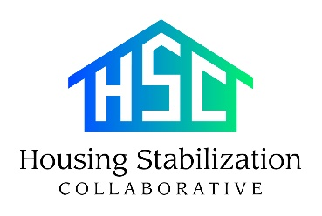

Self-Attestation of Current Income (past 60 days)
Please select any of the following sources of income that your household receives:
❏ Employment income
❏ Unemployment income
❏ Temporary Assistance for Needy Families (TANF), Child support, Social Security income
❏ Self-employment income
❏ Cash income
❏ Wages from a closed business
❏ Wages from Veterans administration, gross rental or lease income, cash benefits
❏ Other (please describe): ___________________________________________________________________________
❏ No income
Please declare the total amounts below:
Month | Amount | Source/Employer
1.
2.
3.
4.
I understand that I am reporting my past and current income to establish my eligibility and the determination of the amount of assistance needed. I declare under penalties of perjury that the foregoing representations of the income for my household are true, correct, accurate, and complete in all respects.

____________________________________________ | ____________________________________________
Name | Date
____________________________________________ | ____________________________________________
Signature | Address

